

**CANDIDATE BRIEF**

Postdoctoral Research Associate, Leeds Arts and Humanities Research Institute, Faculty of Arts, Humanities and Cultures

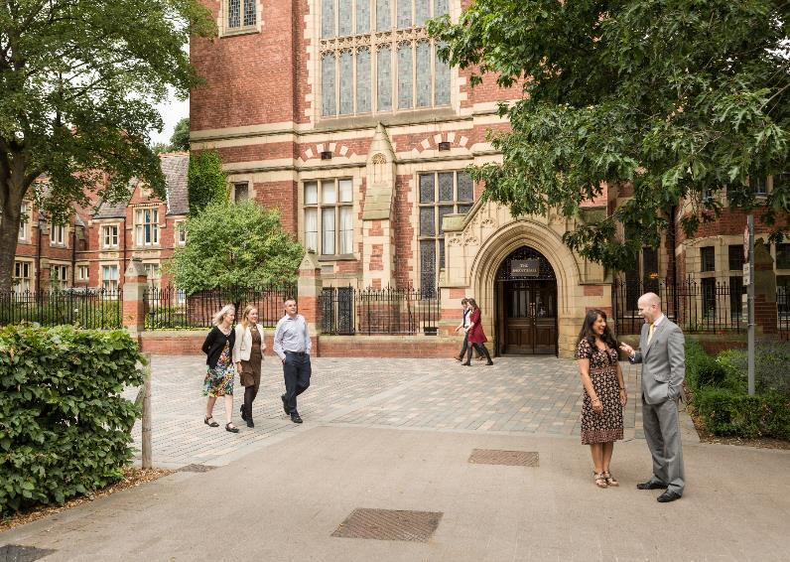

Salary: Grade 7 (£34,304 – £40,927 p.a. pro rata)

Reference: LAHRI PDRA - Scoping

Closing date: 17 March 2022

Start date: 1 April 2022 (or earlier)

Full time, Fixed-term for 3 months due to exteral funding

We will consider job share and flexible working arrangements

**Postdoctoral Research Associate, Leeds Arts and Humanities Research Institute, Faculty of Arts, Humanities and Cultures**

Applications are invited for a Postdoctoral Research Associate to support a Participatory Research Scoping Study. The successful applicant will be supervised by Dr Pammi Sinha.

The Faculty of Arts, Humanities and Cultures has a range of engagements and interactions with community and voluntary organisations within the Leeds City Region. However, we do not currently know the scale or the full significance of these interactions. This scoping study will undertake a review of:

- The range of organisations we have worked with

- The origins and development of collaborative relationships

- Examples of good practice and lessons learned

This will result in a report, which will be shared with the academic community and with community/voluntary groups.

The successful candidate will possess a PhD in the Art, Humanities or Social Sciences, with experience in engaging with community groups and organisations. They will have experience of using qualitative research methods (which may include participatory research methods and or ethnographic methods). The project ambition is to map activity particularly in the Leeds City Region.

Excellent communication and written skills are essential, as is a willingness to work quickly, remotely and independently. Some of the activity of this project may need to take place face-to-face, so you must be comfortable in that working environment. We expect that the PDRA will need to occasionally travel to community groups in the Leeds City Region.

**What does the role entail?**

As a Postdoctoral Research Associate your main duties will include the following activities:

* Using a combination of desk research and interviews, develop an overview of the range of community and voluntary organisations colleagues in the Faculty of Arts, Humanities and Cultures have worked with;
* Outline the intensity/regularity of the interactions with community and voluntary organisations;
* Research and write up a series of short vignettes or case studies that highlight good practice when working with community/voluntary organisations;
* Working alongside other PDRAs conducting related participatory research projects in the Leeds Arts and Humanities Research Institute and the Leeds Social Sciences Institute;
* Storing and managing all data collected as part of the project in an ethical way, conforming to relevant policy and best practice where applicable;
* Presenting findings at relevant events;
* Carrying out any other duties commensurate with the grade and purpose of the post, as directed by the project supervisors.

General responsibilities:

* Carrying out the duties of the post in accordance with the University values of professionalism, inclusiveness, integrity and community, supporting the core value of academic excellence;
* Carrying out the duties of the post in accordance with University standards, policies and procedures and local Faculty / School benchmarks, as appropriate;
* Maintaining a safe work environment, including ensuring compliance with legislation and the undertaking of risk assessments;
* Integrating the University value of inclusiveness into all appropriate aspects of the job; respecting the dignity and diversity of all members of the University community and of visitors to the University.

**What will you bring to the role?**

As a Postdoctoral Research Associate you will have:

* A PhD in the Arts, Humanities or Social Sciences (please note, the PhD must have been awarded by the time of application);
* An understanding of participatory research and/or ethnographic methods;
* Experience in conducting qualitative research;
* Experience of engaging with community groups or volunteer organisations;
* Excellent written and oral communication skills;
* Excellent time management, project management and organisation skills;
* Good IT skills, including experience using Word and Excel;
* Proven ability to work independently and to tight deadlines;
* Flexibility and adaptability, with a proactive and positive approach.

You may also have:

* Experience in conducting quantitative research
* Experience in participatory action research and/or ethnographic methods.

**How to apply**

To apply for this opportunity, please send a copy of your CV, and short covering letter that outlines your suitability for the role and how you meet the requirements listed under ‘what you will bring to the role’.

Applications must be submitted to [LAHRI@leeds.ac.uk](mailto:LAHRI@leeds.ac.uk) by **9am on Thursday 17th March 2022**. Applications received after this time will not be considered.

Interviews will be held on the 24th of March and the start date for the successful candidate will be Friday 01/04/2022

**Contact information**

To explore the post further or for any queries you may have, please contact:

Dr Pammi Sinha, Deputy Director, Leeds Arts and Humanities Research Institute, [P.K.Sinha@leeds.ac.uk](mailto:P.K.Sinha@leeds.ac.uk)

**Additional information**

**Our commitment to inclusion**

As an international research-intensive university with a strong commitment to student education, we aim to create an inclusive environment that attracts, supports and retains the best students and staff from all backgrounds and from across the world.

In line with this vision, the Faculty of Arts, Humanities and Cultures is committed to fostering a culture of inclusion, respect and equality of opportunity. We select candidates on the basis of merit and ability, and aspire to further diversify our Faculty community. We particularly welcome and encourage applications from candidates belonging to groups that have been under-represented in the University including, but not limited to: Black, Asian and ethnically diverse people; people who identify as LGBT+; and people with disabilities.

**Working at Leeds**

Find out more about the benefits of working at the University and what it is like to live and work in the Leeds area on our [Working at Leeds](https://jobs.leeds.ac.uk/display.aspx?id=1697&pid=0) information page.

**Candidates with disabilities**

Information for candidates with disabilities, impairments or health conditions, including requesting alternative formats, can be found on our [Accessibility](https://jobs.leeds.ac.uk/display.aspx?id=1253&pid=0) information page or by getting in touch with us at [disclosure@leeds.ac.uk](mailto:disclosure@leeds.ac.uk).

Criminal record information

**Rehabilitation of Offenders Act 1974**

A criminal record check is not required for this position. However, all applicants will be required to declare if they have any ‘unspent’ criminal offences, including those pending. Any offer of appointment will be in accordance with our Criminal Records policy. You can find out more about required checks and declarations in our [Criminal Records](https://jobs.leeds.ac.uk/display.aspx?id=1711&pid=0) information page.