

**CANDIDATE BRIEF**

Postdoctoral Research Associate, Leeds Arts and Humanities Research Institute and Special Collections, University of Leeds Library

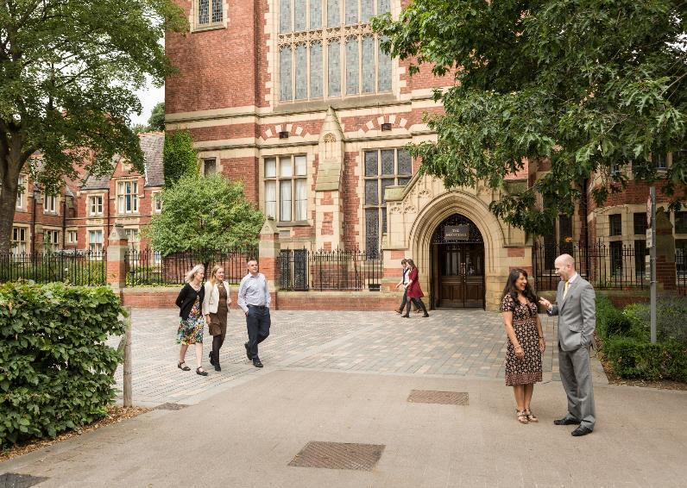

Salary: Grade 7 (£34,304 – £40,927 p.a. pro rata)

Reference: LAHRI- Participatory Research PDRA

Closing date: 14/03/2022 (09:00am)

Start date: 1 April 2022 (or earlier)

Full time, Fixed-term for 3 months due to exteral funding

We will consider job share and flexible working arrangements

**Postdoctoral Research Associate, Leeds Arts and Humanities Research Institute and Special Collections, University of Leeds Library**

Applications are invited for a Postdoctoral Research Associate to support a Participatory Research Project with Special Collections in the University of Leeds Library. The successful applicant will be jointly supervised by Dr Fozia Bora and Joanne Fitton.

Special Collections at Leeds holds numerous valuable items and collections of significant relevance and interest for our local communities. However, many of these collections are currently inaccessible to those beyond the University. This project will work with disengaged communities in Leeds and Bradford to explore how our collections can be made more accessible. Going beyond the aim of displaying items in galleries, it will investigate how we co-curate the material in the Special Collections using a participatory model, what decolonisation means in relation to the collections, and what animates, inspires and facilitates community engagement.

Through a series of ‘labs’ the PDRA will explore how we can break down barriers to access and engagement, and enable participatory research with local communities. The project will provide a model for dialogic research with Special Collections, in line with the Library’s vision of “Knowledge for All” and the University’s Strategy, “Universal Values, Global Change”.

The successful candidate will possess a PhD in the Art, Humanities or Social Sciences, with experience in engaging with community groups and organisations. They will have experience of using participatory research methods. The project ambition is to engage with community groups in the Leeds and West Yorkshire area; in light of this, spoken language skills in addition to English are desirable, for example South Asian languages, Polish, Somali or Arabic.

Excellent communication and written skills are essential, as is a willingness to work quickly, remotely and independently. Some of the activity of this project will need to take place face-to-face, so you must be comfortable in that working environment. We expect that the PDRA will need to travel to community groups in the Leeds/Bradford area.

**What does the role entail?**

As a Postdoctoral Research Associate your main duties will include the following activities:

* Running a series of in-person and online workshops/labs with local community groups, and ensuring findings are captured on the day;
* Reviewing and collating suitable items in Special Collections for the project;
* Writing up a series of recommendations for Special Collections to inform their future community engagement policy;
* Writing up a brief overview of the most successful ways of conducting community engagement;
* Working alongside other PDRAs conducting related participatory research projects in the Leeds Arts and Humanities Research Institute and the Leeds Social Sciences Institute;
* Storing and managing all data collected as part of the project in an ethical way, conforming to relevant policy and best practice where applicable;
* Presenting findings at relevant events;
* Carrying out any other duties commensurate with the grade and purpose of the post, as directed by the project supervisors.

General responsibilities:

* Carrying out the duties of the post in accordance with the University values of professionalism, inclusiveness, integrity and community, supporting the core value of academic excellence;
* Carrying out the duties of the post in accordance with University standards, policies and procedures and local Faculty / School benchmarks, as appropriate;
* Maintaining a safe work environment, including ensuring compliance with legislation and the undertaking of risk assessments;
* Integrating the University value of inclusiveness into all appropriate aspects of the job; respecting the dignity and diversity of all members of the University community and of visitors to the University.
* These duties provide a framework for the role and should not be regarded as a definitive list. Other reasonable duties may be required, consistent with the grade of the post.

**What will you bring to the role?**

As a Postdoctoral Research Associate you will have:

* A PhD in the Arts, Humanities or Social Sciences (please note, the PhD must have been awarded by the time of application);
* Demonstrable expertise in participatory research methods and/or ethnographic research methods;
* Experience of engaging with community groups or volunteer organisations;
* Experience of organising and running workshops/events;
* Excellent written and oral communication skills;
* Excellent time management, project management and organisation skills;
* Proven ability to work independently and to tight deadlines;
* Flexibility and adaptability, with a proactive and positive approach.

You may also have:

* Language skills in addition to English;
* Experience of using archival or unique collection items
* Experience of collaborating with external arts and cultural organisations, especially those based in or working with under-represented communities.

Applicants to this role will need to have the right to work in the UK, and must be available in the Leeds/Bradford area for the duration of the project.

**How to apply**

To apply for this opportunity, please send a copy of your CV, and short covering letter that outlines your suitability for the role and how you meet the requirements listed under ‘what you will bring to the role’. Please also include the details of two references who can be contacted if you are offered the position.

Applications must be submitted to [LAHRI@leeds.ac.uk](mailto:LAHRI@leeds.ac.uk) by **9am on Monday 14th March 2022**. Applications received after this time will not be considered.

Interviews will be held in the week of 21 March, date and time to be confirmed.

**Contact information**

To explore the post further or for any queries you may have, please contact:

Dr Fozia Bora, Associate Professor of Islamic History,

Email: [F.G.Bora@leeds.ac.uk](mailto:F.G.Bora@leeds.ac.uk)

**Additional information**

**Our commitment to inclusion**

As an international research-intensive university with a strong commitment to student education, we aim to create an inclusive environment that attracts, supports and retains the best students and staff from all backgrounds and from across the world.

In line with this vision, the Faculty of Arts, Humanities and Cultures is committed to fostering a culture of inclusion, respect and equality of opportunity. We select candidates on the basis of merit and ability, and aspire to further diversify our Faculty community. We particularly welcome and encourage applications from candidates belonging to groups that have been under-represented in the University including, but not limited to: Black, Asian and ethnically diverse people; people who identify as LGBT+; and people with disabilities.

**Working at Leeds**

Find out more about the benefits of working at the University and what it is like to live and work in the Leeds area on our [Working at Leeds](https://jobs.leeds.ac.uk/display.aspx?id=1697&pid=0) information page.

**Candidates with disabilities**

Information for candidates with disabilities, impairments or health conditions, including requesting alternative formats, can be found on our [Accessibility](https://jobs.leeds.ac.uk/display.aspx?id=1253&pid=0) information page or by getting in touch with us at [disclosure@leeds.ac.uk](mailto:disclosure@leeds.ac.uk).

Criminal record information

**Rehabilitation of Offenders Act 1974**

A criminal record check is not required for this position. However, all applicants will be required to declare if they have any ‘unspent’ criminal offences, including those pending. Any offer of appointment will be in accordance with our Criminal Records policy. You can find out more about required checks and declarations in our [Criminal Records](https://jobs.leeds.ac.uk/display.aspx?id=1711&pid=0) information page.