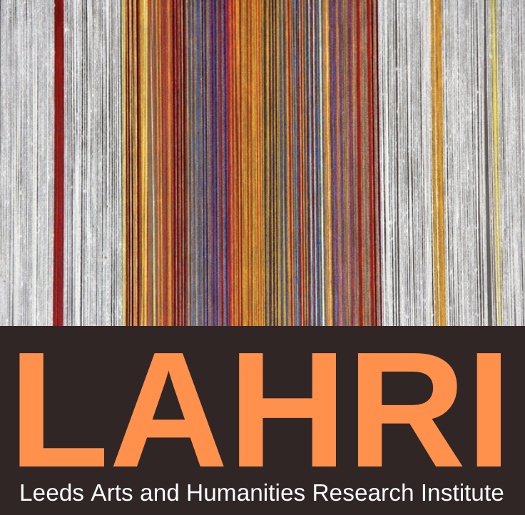

Leeds Arts and Humanities Research Institute

Postdoctoral Fellowship Application Form
University of Leeds PhD students in the Faculty of Arts, Humanities and Cultures who have recently submitted their completed theses, or have recently passed their doctoral vivas, are invited to apply for a Postdoctoral Fellowship in the Leeds Arts & Humanities Research Institute (LAHRI). Up to eight Fellowships will be awarded in each round.
This scheme is intended to give promising early-career researchers the support needed to advance their research and their careers in the period between thesis completion and the taking up of a first academic post. While the Fellowships are non-stipendiary, we are able to offer successful applicants full access to the University of Leeds computing, printing and other digital resources. Fellows will be given a staff email account, access to the Library’s resources, OD&PL professional development opportunities, as well as online research training and workshops that have been developed by LAHRI specifically for arts and humanities researchers transitioning to independence. In the last 12 months we have developed new virtual mechanisms to ensure that our Fellows can benefit from the interaction with other researchers that is vital to the life of a flourishing interdisciplinary research community. We can offer bespoke research support to individuals. And, when it is safe to do so, successful applicants will be offered the use of desk space and event space in LAHRI’s Clothworkers South rooms. Fellows also have the opportunity to apply for up to £500 to support their research activity during their stay in the LAHRI.
Fellowships can last for six or twelve months. Under exceptional circumstances, Fellowships may be renewed or extended. We warmly welcome applications from International students, but please note that students will be unable to take up a LAHRI Fellowship until necessary assessments have been made of their postdoctoral immigration status. We are now able to consider requests for fully remote Fellowship applications.
We appreciate that Fellows are likely to be combining this with paid employment; therefore, there is no stipulation as to your attendance at the Institute (physically or virtually), though of course we hope that our Fellows will take every opportunity to benefit from being part of a wider research community.
Application process
Applications must be submitted to lahri@leeds.ac.uk. The deadline for the current round of applications is 23:59 on Thursday 24 February for Fellowships to begin from April 2022
Applications should consist of electronic versions of (1) a completed application form; (2) a CV (max. 2 pages); (3) a scanned copy of your passport (and visa if applicable).
Applicants will be notified of the outcome by Thursday 10 March 2022 and Fellowships awarded can begin between 1 April 2022 to 31 June 2022. If you are unable or ineligible to start between these dates, then you will be invited to reapply in a later round.
Eligibility
This scheme is open to University of Leeds PhD students in the Faculty of Arts, Humanities and Cultures who have recently submitted their completed theses, or have recently passed their doctoral vivas. If offered a Fellowship you will only be able to accept it once you have passed your viva outright, or subject to any presentational or minor defects (minor corrections) have been approved?

Application Form

Please refer to the guidance above before completing this form. The form must be completed electronically, submitted to lahri@leeds.ac.uk by the relevant deadline, and accompanied by the additional documentation outlined above.

SECTION 1 – Applicant Details

Title and Name:
Full postal address:
(NON-UNIVERSITY) Email address:
Phone:
Date of submission of PhD thesis (or pass date of doctoral viva):
AHC Parent School attended to complete PhD:
Details of any current employment:
Nationality:

SECTION 2 – Project details – to be completed by the prospective fellow

- Project title:
- Project Description:
Please provide a research proposal of no more than 300 words outlining any specific outcomes that you anticipate will arise from this position. These might include:

- Plans for publication
- Impact-related activities
- Development of grant applications
- Conference papers
- How your research will benefit from you participating in the LAHRI community

SECTION 3 – Timescales

Proposed start date of Fellowship:

Proposed duration of Fellowship (please delete as appropriate): 6 or 12 months

